Campus Connect

Mr.Pranav .A. Pathak

Assistant Professor

Computer Science And Engineering Dept

Arvind Gavali College Of Engineering, Satara,India

pranav.pathak@agce.edu.in

Mr.Nishant Vitthal Dhumal

Computer Science And Engineering Dept

Arvind Gavali College Of Engineering, Satara,India

nishanthdhumal@gmail.com

Mr.Rushikesh Anil Katkar

Computer Science And Engineering Dept

Arvind Gavali College Of Engineering, Satara,India

katkarrushikesh2002@gmail.com

Mr.Shubham Popat Ghadge

Computer Science And Engineering Dept

Arvind Gavali College Of Engineering, Satara,India

shubhamghadge784@gmail.com

***Abstract*—Nowadays, whenever a student are completed their degree in engineering or other then he/she have to identify that in which company they can approach according to the different criteria’s of companies.** **Student have to check criteria’s of every company to check whether they can apply for the job or no. Students who are trying for off campus placement have these as a big issue in market. For that we in traduce our website name as “Campus Connect: A Student Placement Hub” which identifies the companies for students according the different criteria’s of company**. **This is also helpful for students who are prepare for placement in next upcoming year and also for different degree level and wide verities of technical area. One’s a student build their profile then he/she get the list of company in their profile with the company career page link for approaching for placement.**

1. INTRODUCTION

Self Analysis and Placement is the platform on which user can figuring out in which company they can apply and user also search companies according their interest and get information about their placement criteria. This platform shows result according the user interest and help to get companies, And it gives the list of companies in which job is available according to users skills and experience.

This platform having two login’s first is for students and other is for college TOP’s. Admin can view their student information and their profile and share overall and individual student profile to the company HR directly.

Student have to check criteria’s of every company to check whether they can apply for the job or no. so, this problem get solve by our website. Students who are trying for off campus placement have these as a big issue in market. For that we in traduce our website name as “Campus Connect: A Student Placement Hub” which identifies the companies for students according the different criteria’s of company.

This is also helpful for students who are prepare for placement in next upcoming year and also for different degree level and wide verities of technical area. One’s a student build their profile then he/she get the list of company in their profile with the company career page link for approaching for placement.

Campus Connect harnesses the power of advanced algorithms to deliver tailored recommendations based on each student's unique profile, including academic achievements, skills, interests, and career aspirations.

With Campus Connect, students gain access to comprehensive information about participating companies, including placement criteria, job openings, and career advancement opportunities. This transparency empowers students to make informed decisions and ensures alignment with their career goals. Beyond immediate job placements, Campus Connect equips students with the tools and resources needed to thrive in their careers.

1. RELATED LITERATURE REVIEW
2. *Introduction to Campus Connect:* ***Technology in Student Placement:***

Technology has emerged as a powerful tool in facilitating student placement and bridging the gap between education and employment. Previous studies have underscored the importance of leveraging technology to provide personalized guidance and support to students as they navigate the job market. By harnessing advanced algorithms and data analytics, platforms like Campus Connect offer tailored recommendations based on students' academic backgrounds, skills, and career aspirations, thereby enhancing the efficiency and effectiveness of the placement process.

1. ***Enhancing Student-Industry Connectivity***

One of the key objectives of student placement platforms is to foster greater connectivity between students and prospective employers. Research has shown that direct engagement with industry professionals and access to comprehensive company information are critical factors in students' career decision-making process. Campus Connect addresses this need by providing students with insights into various companies' placement criteria, job openings, and career advancement opportunities, thereby empowering them to make informed decisions about their future career paths. In addition to providing insights into companies' placement criteria and job openings, Campus Connect actively facilitates networking opportunities between students and industry professionals.

1. *Case Studies and* ***Administrative Support and Oversight:***

In addition to serving students, placement platforms also play a crucial role in supporting college administrators in managing student profiles and facilitating communication with employers. Studies have highlighted the importance of administrative oversight in ensuring the smooth functioning of the placement process and maximizing students' opportunities for success. Campus Connect offers dedicated login portals for both students and college administrators, enabling efficient management of student profiles and seamless communication between colleges and companies. Beyond facilitating initial job placements, Campus Connect supports students' long-term career growth by providing access to career advancement opportunities within partner companies.

1. OBJECTIVE

The proposed website aims to serve as a comprehensive platform catering to the needs of students and job seekers by facilitating their search for suitable employment opportunities. Through an intuitive user interface, users will be able to navigate seamlessly, accessing a robust filtering system to match their skills and criteria with the best-suited companies. Detailed profiles of each company, including placement criteria and career page links, will empower users with valuable insights into various industries, aiding in their decision-making process. An integrated admin panel will streamline communication between administrators and companies, allowing for the efficient sharing of student data and profiles. Additionally, the implementation of a predictive analytics system will enable the website to forecast placement outcomes, helping users gauge their likelihood of success. With a focus on user authentication and data security, coupled with rigorous testing and quality assurance measures, the website will ensure a secure and reliable experience for all users.

1. METHODOLOGY

Your campus connect project. Here's a structured breakdown you can follow:

**User Input:**

Users are presented with a user-friendly interface where they can input their information through a series of forms or questionnaires. These forms may include fields for skills, education level, preferred industry, desired job roles, location preferences, and any other relevant criteria. The input process is designed to be intuitive and straightforward, guiding users through the necessary steps to provide comprehensive information about their background and career aspirations.

**List of Companies:**

After submitting their information, users are directed to a dynamically generated list of companies that match their specified criteria.

This list is generated based on an algorithm that analyzes the user's input and compares it against a database of companies with available job openings. The list may be sorted by relevance, with the most closely matched companies appearing at the top, or by other criteria such as industry .

**Login Requirement:**

To access detailed information about the listed companies and their job openings, users are required to log in to their account. This login requirement helps ensure privacy and security by restricting access to sensitive information. Users are prompted to log in using their email address and password, or they may have the option to log in through social media accounts for added convenience.

**Login Prompt:**

If a user attempts to access company information or the job section without being logged in, a modal or pop-up window appears, prompting them to log in or create an account. The prompt may include options for users to recover their password or sign up for a new account if they don't already have one. Clear instructions and call-to-action buttons guide users through the login process.

**Company Information:**

Upon successful login, users gain access to detailed information about each company in the list. This information may include the company's name, industry, location, size, mission statement, values, recent achievements, employee testimonials, and any other relevant details that provide insight into the company's culture and values. Users can click on each company profile to view more information and explore available job openings.

**Job Search Functionality:**

The job search functionality allows users to input their preferences and filter job listings according to their desired criteria. This helps users find relevant job opportunities efficiently.

**Search Results:**

After conducting a job search, the user is presented with a list of job openings that match their specified criteria. Each listing includes key details such as job title, company name, location, and application deadline.

**Application Process:**

Users can then click on individual job listings to view more details and initiate the application process. Depending on the company's requirements, users may be directed to apply directly through the website or redirected to the company's career page.

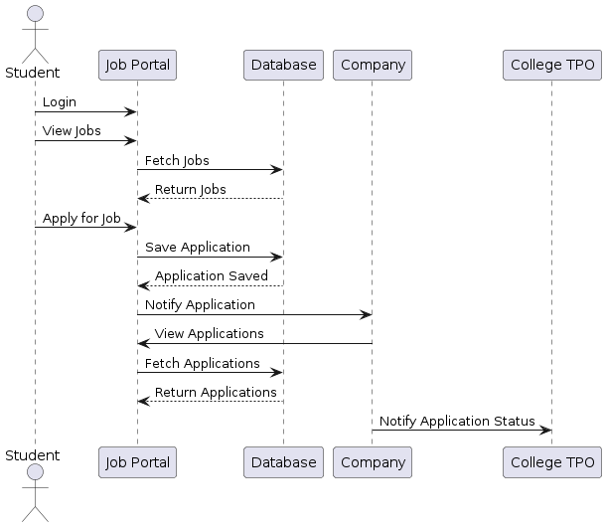

V. RESULT

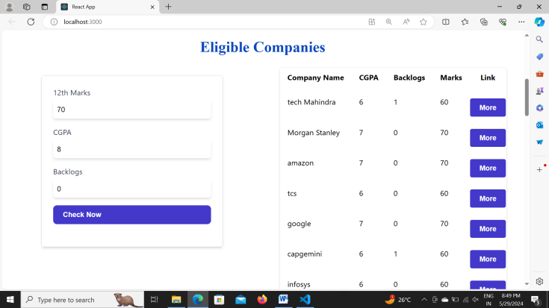

As a student, you have access to our comprehensive placement assistance portal. Upon logging in, you'll be prompted to input your academic credentials, including your 10th and 12th marks, CGPA, and the number of backlogs. Once you've entered this information, our system will generate a list of companies that align with your academic profile. You can then explore each company to learn more about them and apply to the ones that interest you.

Companies partnering with our placement assistance portal have their own dedicated login. When a student applies to a company, the application is immediately visible in the company's login portal. Companies can review each application thoroughly, considering the student's academic background and any additional information provided. They can then choose to accept or reject the application based on their hiring criteria. Upon making a decision, the company can notify the student via email directly through our platform.

The TPO plays a pivotal role in facilitating the placement process. Through their login portal, TPOs can oversee the entire placement landscape. They have visibility into which students have applied to which companies, allowing them to track the progress of each student's job search. Additionally, TPOs can provide guidance and support to students, helping them navigate the application process effectively.

Communication is key throughout the placement process. Our system ensures seamless communication between students, companies, and TPOs. When a student applies to a company, both the company and the TPO are notified. Similarly, when a company makes a decision on an application, the student and the TPO receive notifications accordingly. This streamlined communication process ensures transparency and keeps all stakeholders informed at every step of the way.

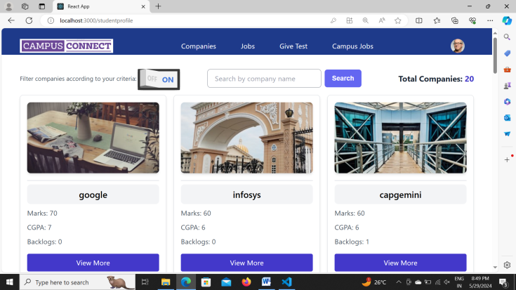

VI. CONCLUSION AND FUTURE SCOPE

In conclusion, our placement assistance portal revolutionizes the job search and recruitment process by seamlessly connecting students, companies, and Training and Placement Officers (TPOs). Through intuitive login portals tailored to each user role, we facilitate efficient communication and interaction.

For students, the portal serves as a gateway to explore job opportunities based on their academic achievements. By inputting their 10th and 12th marks, CGPA, and backlog information, they receive tailored recommendations of companies that align with their profile. This empowers students to make informed decisions and apply to positions that best suit their skills and aspirations.

TPOs play a crucial role in facilitating the placement process. With access to comprehensive data on student-company interactions, TPOs can provide guidance and support to students, ensuring they navigate the job search process effectively. Additionally, they can track the progress of each student's job search journey, offering assistance where needed.

Overall, our placement assistance portal fosters transparency, efficiency, and collaboration among all stakeholders involved in the placement process. By leveraging technology to bridge the gap between students and companies, we strive to create a dynamic ecosystem where talent meets opportunity. Welcome to a new era of streamlined placement assistance, where success is just a click away!

Integrating coding exams into the portal allows students to showcase their programming skills directly to potential employers. Students can take coding challenges tailored to various skill levels and programming languages. These exams not only serve as a benchmark for assessing a student's technical proficiency but also provide companies with a standardized way to evaluate candidates' coding abilities. Results from coding exams can be included in students' profiles, giving them an edge during the recruitment process.

Aptitude exams measure a candidate's cognitive abilities, problem-solving skills, and critical thinking capabilities. By incorporating aptitude tests into the portal, students can assess their readiness for employment and identify areas for improvement. Companies can use aptitude exam scores as additional criteria when evaluating candidates, ensuring a comprehensive assessment of their potential. Moreover, personalized feedback and recommendations based on aptitude exam performance can help students enhance their skills and increase their employability.

REFERENCES

1. Sonal Kureshi The IUP journal of marketing management, Vol.9 Nos 1& 2 2010-05-26
2. Vandana Sood Conceptual and Managerial implication “The usage placements is increasing across media making it essential for us to understand its effect on the audience”. 2010
3. Nilesh Rathod As Interactive online Training and Placement system “College talent placement system at providing the facility to automate and simplify the process of registration and list generation of eligible students for placement”. 201
4. Shilpa Hadkar College collaboration portal with training and placement “The project will indicate manual work and maximize optimization, abstraction and security. Students will get notify when TPO’s upload study material or any campus drive information through the system”.
5. Rampalli Paya, Ganesan Palanisamy, S.K.V Jayakumar Mediterranean journal of social “Campus recruitment is the process by which the corporate recruit students who are about to graduate from the educational institution”. 2015.
6. Suraj Gupta “Recruitment system with system prediction “This concept is used to determine in next step to determine or predict employee placement based on their characteristics” 2021.